Using Balls to Support Your Child’s
Prepositions
See if your child can follow simple instructions that include the prepositions ‘in’, ‘on’ and ‘under’.
Eg- ‘Put the ball on the table’,
‘Put the ball in the box’,
‘Put the ball under the chair’.
Speech
Work on the initial ‘b’ sound and encourage your child to make the ‘b’ sound when the ball is bouncing.
Roll a dice and ask your child to bounce the ball the amount of times shown on the dice, each time making the ‘b’ sound.
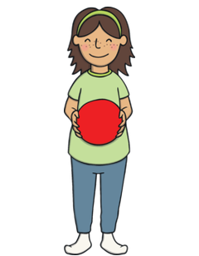
Interaction Skills
Making choices – use two different coloured balls and encourage your child to make a choice.
Turn-taking- take it in turns to roll or throw the ball into a box or through a hoop.
Requesting- encourage your child to ask for ‘more’.
Listening- encourage your child to wait for a certain phrase before rolling or throwing the ball. Eg- “ready, steady, go!”
Developing shared attention- look at the ball when it is rolled or thrown and encourage your child to look with you.

Expressive Language Skills
One word phrases- use words such as ‘go’ ‘throw’, ‘stop’, ‘more’, ‘in’, ‘roll’, ‘ball’, ‘bounce’ and ‘again’.
Simple phrases- encourage your child to use ‘ready, steady, go!’
Colours- use different coloured balls to help with descriptive skills eg ‘look at this blue ball!’
Size- eg. ‘Big ball’, ‘small ball’.
Verbs – eg ‘throw’, ‘kick’, ‘roll’, ‘bounce’.
Concepts – eg ‘hard/soft’,’ up/down’, ‘fast/slow’
Speech and Language Development

