Using Bricks to Support Your Child’s
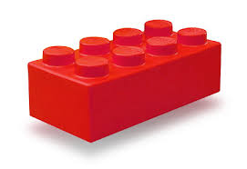
Speech and Language Development
Expressive Language Skills
One word phrases- use words such as ‘go’ ‘brick’, ‘stop’, ‘more’, ‘on’, ‘tower’ and ‘again’.
Simple phrases- encourage your child to use ‘ready, steady, go!’ and ‘more bricks please’.
Colours- use different coloured bricks to help with descriptive skills eg ‘yellow brick next’.
Size- talk about the different sizes of bricks. eg. ‘Big brick’, ‘small brick’.
Verbs – use words like, ‘build’ and ‘make’.
Concepts – eg ‘’top/bottom’, ‘up/down’ and ‘same/different’.
Numbers- Encourage your child to count the bricks with you
Chant and Sing
After building a tower, make up silly songs/chants.
Eg- ‘wibble wobble, wibble wobble, ready steady go!’ Leave a small pause then let your child knock the tower down.
Speech
Build a tower with your child and work on the initial ‘t’ sound. Encourage your child to make the t’ sound when they put a brick on the tower.
Use some different sound cards and put them under the bricks. Encourage your child to choose a card and say the sound on the card before adding the brick to the tower.
Creativity
Encourage your child to build whatever they want to and talk about what they have made.
Eg- ‘you have made a big house’.
Interaction Skills
Making choices – hold out two different coloured bricks and encourage your child to make a choice.
Turn-taking- take it in turns to add bricks to the tower.
Requesting- encourage your child to ask for ‘more bricks’.
Developing shared attention- look at the ball when it is rolled or thrown and encourage your child to look with you.



