Using Bubbles to Support Your Child’s
Speech and Language Development
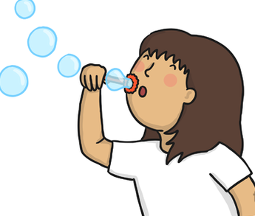
Interaction Skills
Turn-taking- take it in turns to blow bubbles. Who can blow the most?
Requesting- encourage your child to ask for ‘more bubbles’ and for help taking the lid off.
Listening- encourage your child to wait for a certain phrase blowing more bubbles. Eg- “ready, steady, BLOW!”
Eye contact- encourage your child to make eye contact with you before blowing the bubbles.

Speech
Choose a sound to practise and say it whilst popping the bubbles.
Eg- ‘p.p.p.p.p.p.p’ or ‘s.s.s.s.s.s.s.s’
Encourage your child to copy you.
Also use words such as ‘pop’ and ‘bubbles’ to practise the ‘p’ and ‘b’ sounds.
Oro-Motor Skills (mouth movements)
Let your child practise putting their lips together and blowing.
They can try blowing air on their hand first and see how many times they can blow!
Expressive Language Skills
Use one word phrases- use words such as ‘bubbles,’ ‘blow’, ‘go’, ‘more’, ‘pop’, ‘gone’ and ‘again’.
Simple phrases- encourage your child to use ‘ready, steady, go/blow!’, ‘more bubbles’, ‘pop bubbles’, ‘open bubbles’.
Quantity- encourage your child to help you count the bubbles. Use language such as, ‘few bubbles’, ‘lots of bubbles’.
Size- eg. ‘big bubble’, ‘small bubble’.
Vocabulary- encourage your child to name different parts of their body whilst trying to get the bubbles to land there.


