Developing Your Child’s Language in Everyday Situations
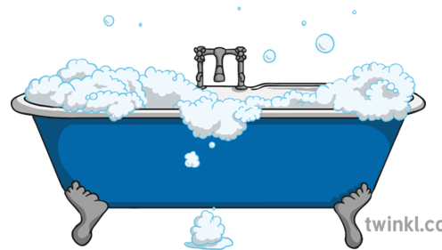
Bathtime Routine
Body vocabulary:
Reinforce the names of body parts and they’re used for.
Try singing ‘head, shoulders, knees and toes together’.
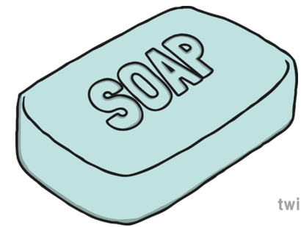

Bathroom nouns:
Use the words soap, shampoo, bubbles, towel, bath, toilet etc
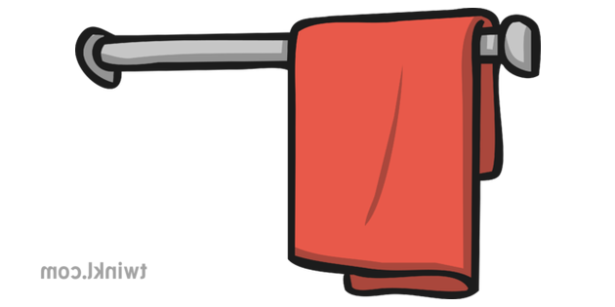
Hot and cold:
Compare the temperature of the water in the bath with the water that comes out of the cold tap.
On and off:
Use these words when dressing and undressing.
In and out:
Talk about getting in and out of the bath/shower and squeezing shampoo out of the bottle.

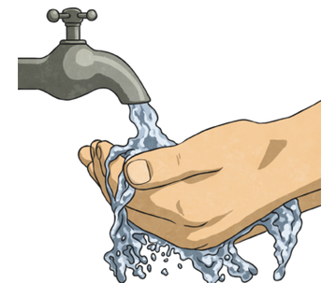
Dirty and clean:
Compare different parts of the body before and after a bath/shower.
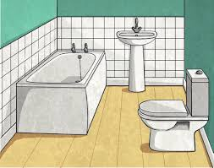
Action verbs:
Demonstrate action words such as- wash, clean, dry, brush, dress, undress.
Full and empty:
Watch the bath being filled up and emptied. Look at how much shampoo is left in the bottle.

