Developing Your Child’s Language in Everyday Situations
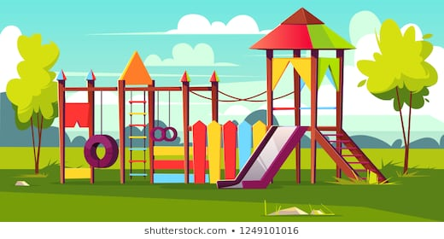
Going to the Park
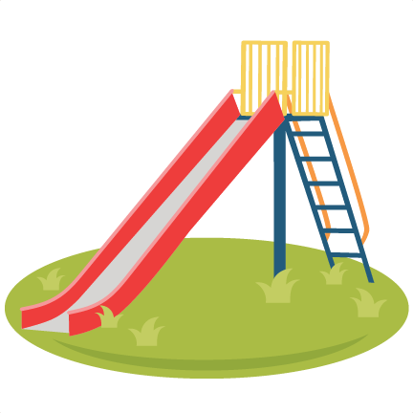
Fast and slow:
These can be used on lots of equipment.
Eg- ‘you went down the slide really fast’,
‘the roundabout is going slow’.
On and under:
Use when your child is using the equipment. Eg- ‘you are under the slide’.
‘you are on the swing’.
Open and close:
Use these words when going through park/playground gates.
High and low:
Model these concepts when playing on the swings.
Eg- ‘you are swinging high!’.
Up and down:
Demonstrate these concepts when using the see-saw and slide.
Action verbs:
Demonstrate words and activities such as running, jumping, sliding, swinging, climbing and walking.
First and last:
Use these positional words when queuing for play equipment or for an ice-cream!
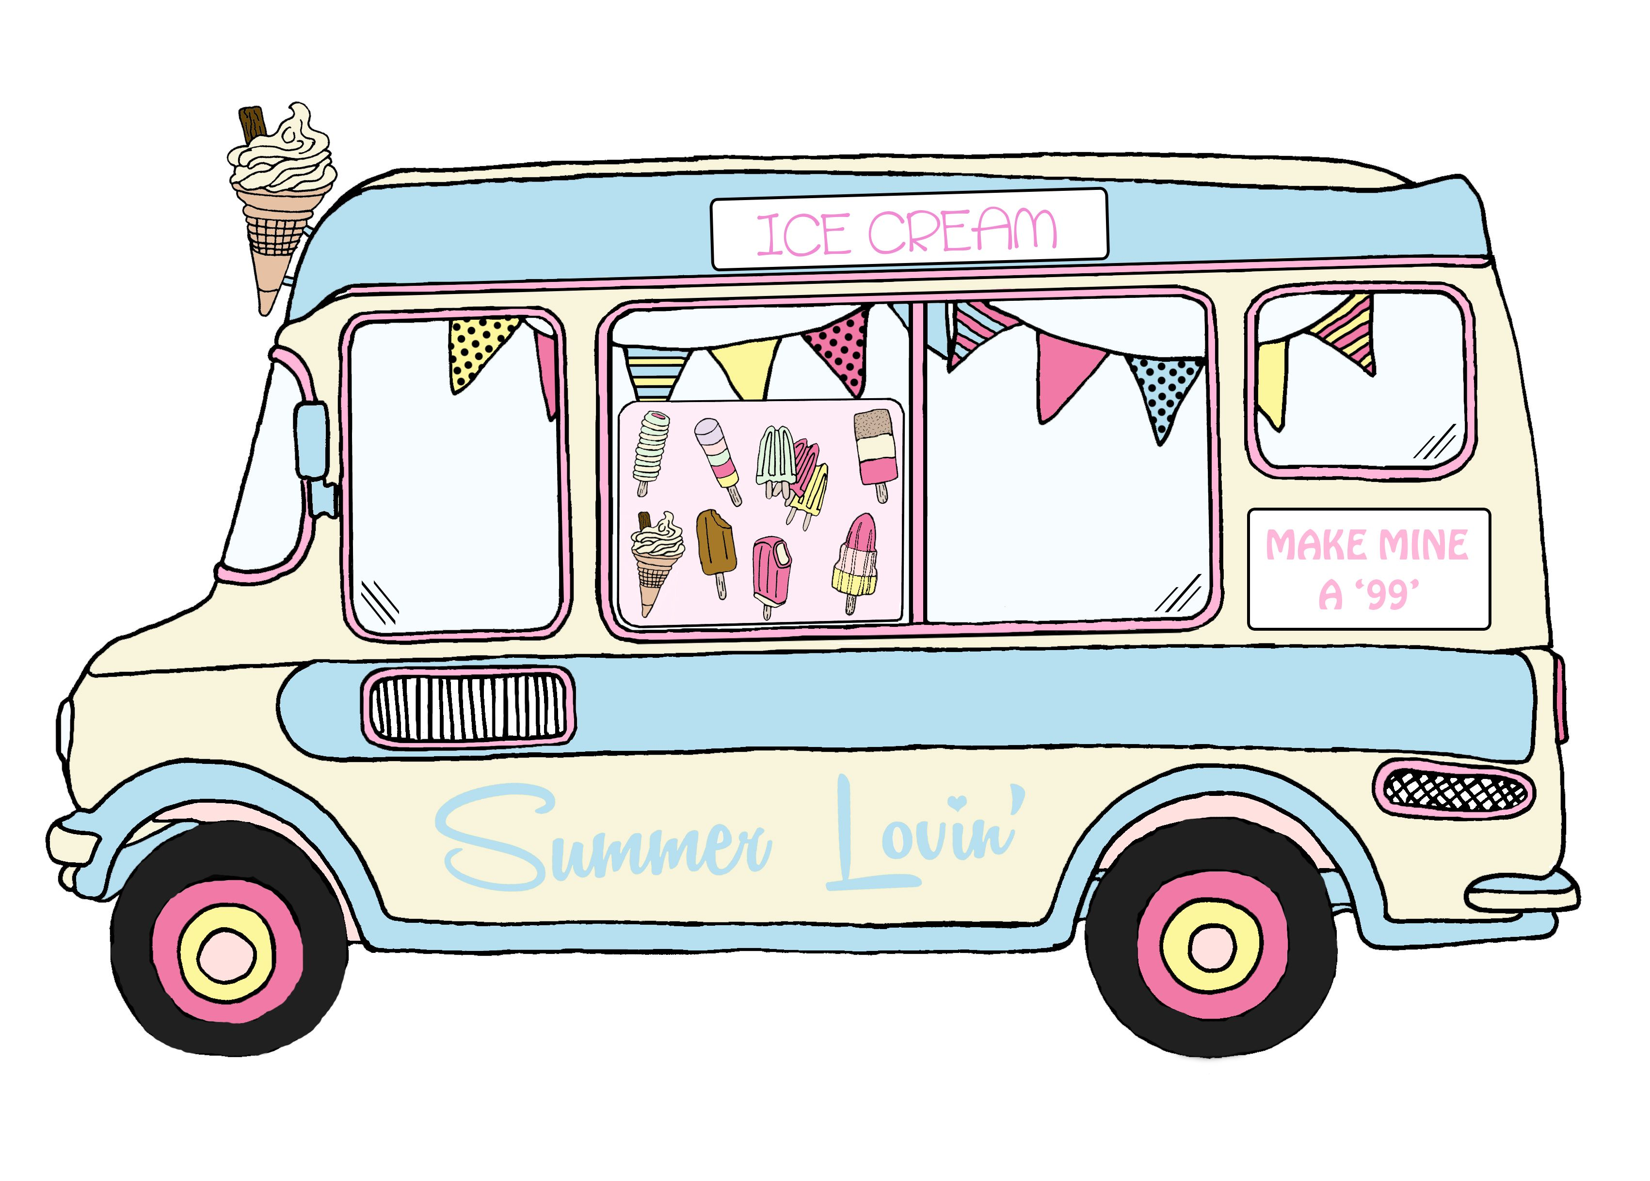
Play equipment:
Label the different pieces of equipment.
Eg- swing, slide, climbing frame and see-saw.


