Developing Your Child’s Language in Everyday Situations
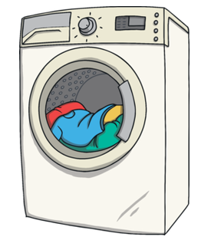
Helping with Laundry
Long and short:
Ask your child to help to sort out socks and match the pairs. Which are long and which are short?
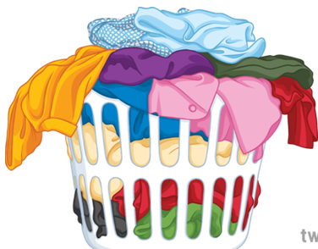
Memory and listening:
Encourage your child to listen to and remember instructions.
Eg- ask your child to put the t-shirt, trousers and socks in the machine in the correct order.
Make the task harder or easier if needed.
In and out:
Use these words and encourage your child to help put things ‘in’ and take things ‘out’ of the washing machine.
Open and closed:
Use these words when opening and closing the washing machine.
Full and empty:
Talk about how the washing machine is full when you put clothes in it and empty when you take them out.
Dirty and clean:
Use these words to compare the laundry before and after it has been washed.
Colours and patterns:
Look at the different colours of clothes and patterns and encourage your child to describe them.
Look for stripes and spots!

Wet and dry:
Compare the washing before and after the wash. How does it feel?


