Developing Your Child’s Language in Everyday Situations
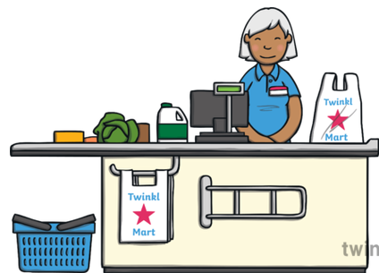
Shopping

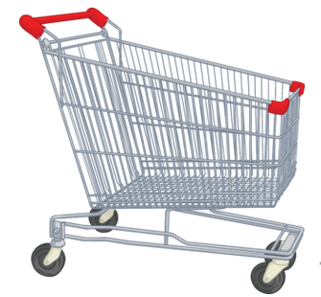
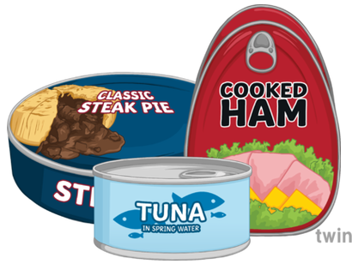
In and out:
Use these words when putting food in the trolley/basket and taking it out to pay.
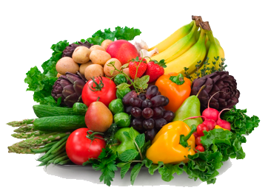
Prepositions:
Top, middle or bottom?
In front or behind?
Talk about where items are on the shelf.
First and last:
Use these positional words while waiting in the queue to pay.
Catergories - Fruit and vegetables:
Talk about the different varieties of fruit and vegetables. What colours are they?
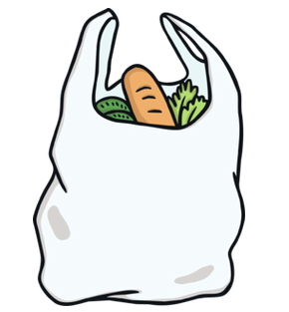
Turn taking and description:
Take it turns to put items into the trolley/basket.
Encourage your child to describe the item they have put in.

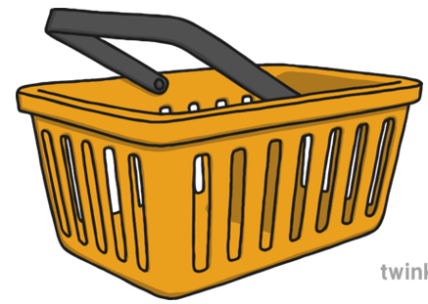
Cold:
Encourage your child to touch something from the frozen section and discuss why it is cold.
Push and pull
Demonstrate these words when using the shopping trolley.
Verbs- Eating and drinking:
Model some interesting words to your child, such as: ‘chew’, ‘munch’, ‘sip’ and ‘slurp’.

